The terms Candidate for Foster Care (CFC) and Foster Care Candidate (FCC) are interchangeable.

Candidate for Foster Care (CFC) or Foster Care Candidate (FCC)
Question: When does this program come into effect?
Answer: FCC has been available through IV-E administrative funding for many years. This webinar was an overview of the current requirements to ensure agencies were aware of the funding source.
Question: Is this all new information, or is this to highlight what has already existed in the case plan for a while now?
Answer: This is the latter, highlighting existing information.
Question: If a child is removed from their parental home and placed in the temporary custody of a relative by the Court, based on recommendation of the PCSA, are these youths still considered to be an FCC? The youth would have been placed in foster care if a relative caregiver was unavailable.
Answer: Once the child is removed from the home they are no longer a foster care candidate.
Question: Since there is a 6-month review requirement, does this mean the IV-E worker will have to do redetermination every 6 months?
Answer: No, the caseworker (service team/ongoing service team) are responsible for FCC redetermination because it is based on identifying/determining whether the child remains at serious/imminent risk of removal. FCC is not based on being IV-E eligible.
Question: Does FCC require that a child’s financial record be kept? If so, what should be in the FCC record? Or, is it the same as FCM requirements 5101:2-47-09?
Answer: FCC does not require a separate financial record for the child, as it is not based on IV-E eligibility.
Question: If JFS is involved and we give temporary custody to a relative, and we are still court involved with reunification as the goal, is the child still a candidate?
Answer: No. Once a child is removed from their parent and custody is given to a relative, they are no longer a candidate.
Question: Will this program be audited by the Feds and State?
Answer: Yes. FCC may be audited by both the Feds and the State.
Question: Is case plan and candidacy functionality already in SACWIS? If Not, when will it be available?
Answer: Yes. The case plan and FCC functionality already exist in SACWIS.

Question: What would be the status if a safety plan is in place and the children are living with grandma?
Answer: It would be up to the agency to decide if these children are at serous/imminent risk of removal into foster care. Safety planning is one way of identifying that a child is not safe in their own home and/or in the care of their parent(s). However, the agency must document that the child is at risk of entering foster care if safety planning is not successful.
Question: Could you provide an example of a case that would NOT qualify for foster care candidacy?
Answer: One example is a case where a family has been identified as having safety issues that need service intervention, but the child is not a serious risk of removal.
Question: If the child was removed and placed in custody of a relative, and we are working on reunification, does that make the child an FCC?
Answer: No. Once a child is removed, they can no longer be an FCC.
Case Plan and Signatures
Question: What is the most important thing to include on the case plan?
Answer: A sentence or two that states, “in the absence of preventative services, this child(ren) would be placed in foster care,” or something similar.
Question: Does a family service plan count as a case plan for this determination?
Answer: Yes, as long as it’s a plan jointly developed with the caregiver(s) and is clearly documented that the services provided are to prevent removal of the child(ren) into foster care.
Question: Where is the FCC section that you are showing on the case plan?
Answer: It is under the topics within the case plan. A screen shot is below.

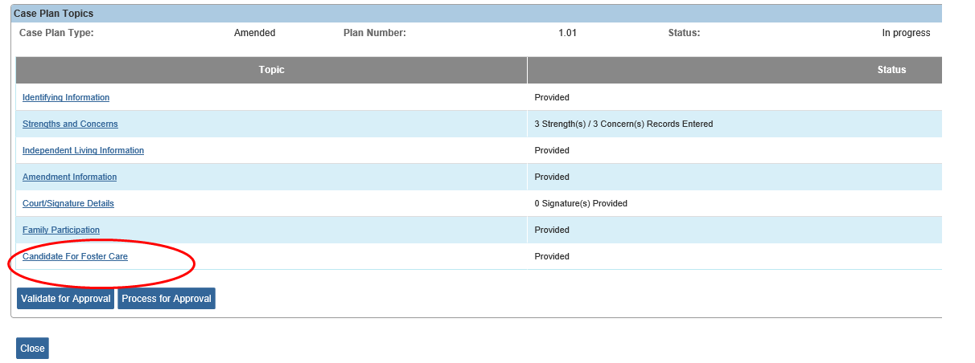
Case Review and Signatures
Question: The SAR counts as the case plan review, correct? Do the signatures and documentation of invitation to all case plan participants count as part of the case plan review, or, does a new case plan need to be completed every 6 months?
Answer: Yes, the SAR can count as the case plan review. Parental signature, or efforts to obtain parental signature, is required, showing their understanding of the child’s candidacy for foster care.
Question: If parents don’t come to the case review, therefore, their signature is not obtained, is documenting in the activity log that reviewed the case plan with the family during a home visit enough documentation?
Answer: If parents did not attend the review, but the agency reviews with the parents at a different date and signatures are provided by parents within the 6 months, this would meet required documentation.
Question: If a parent was invited to the CR/SAR and there is a letter in the file documenting their notification, and then the parent doesn’t attend the CR/SAR and we aren’t able to get their signature, are we to still gain their signature after the fact for the documentation purpose?
Answer: If parents did not attend the review, but the agency reviews with the parents at a different date and signatures are provided by parents within the 6 months, this would meet required documentation.
Question: Why would they be signing a case plan amendment solely for the purpose of gaining their signature to acknowledge FCC since they didn't show for an SAR?
Answer: A case plan amendment would only be necessary if changes are being made to the case plan, such as the child was an FCC, and upon review, the child is no longer an FCC.

Question: If the family does not attend the SAR meeting and the caseworker is not able to meet with the family can you use the mailing of the SAR to the family with the return of the parent signature as the requirement for foster care candidacy?
Answer: This is not the intent of FCC. The intent is that there is a conversation/engagement of the parent to identify safety issues that are causing the serious/imminent risk of removal of the child into foster care and that the parent understands that absent the identified services/behavior changes that is the agency’s next step. Expectation would be that if parent(s) did not attend Case Review/SAR the caseworker would meet with parent and obtain their signature within the 6-month requirement to acknowledge their understanding that their child is a FCC.
Question: Often parents are invited to the SAR but do not attend. The finished document is mailed to the family with the results of the review. Is documentation of the efforts to have the parents attend and then documentation of mailing the SAR to them, sufficient to count as review of the FCC issue with the parent?
Answer: No, an SAR invitation and the mailing of a completed SAR is not acceptable documentation of parental involvement. Expectation would be that if parent(s) did not attend Case Review/SAR the caseworker would meet with parent and obtain their signature within the 6-month requirement to acknowledge their understanding that their child is a FCC.
Question: Is effort to obtain parental signature count as the SAR invitation to the actual meeting? Or is a worker expected to go out an obtain a signature after the scheduled SAR meeting if they do not show up?
Answer: No, an SAR invitation is not acceptable documentation of parental involvement. Expectation would be that if parent(s) did not attend Case Review/SAR the caseworker would meet with parent and obtain their signature within the 6-month requirement to acknowledge their understanding that their child is a FCC.
Determination/Redetermination
Question: Who determines if the child is at serious or imminent risk for FCC? The court or agency?
Answer: It can be either - as the agency providing services and assessments the documentation can show candidacy. As well, court orders can state this.
Question: Can we create our own form that parents & caseworkers sign every six months to document continued fc candidacy?
Answer: We would recommend the Semi-Annual Review.

Alternative Response
Question: How does this work for Alternative Response cases?
Answer: The same as with traditional response cases. The agency assesses and identifies a child that is at serious/imminent risk of removal utilizing assessments, tools, etc. Then the agency either files for custody of the child or creates a case plan that identifies the child is a FCC and that absent the services outlined in the family service plan the child would be placed in foster care.
Question: FCC is not an option on the AR family service plan... is it okay if the correct wording is placed within the body of the FSP?
Answer: Yes, since FCC is not an option on the AR family service plan. The agency would enter the FCC information within the body of the family service plan.
Question: Where in SACWIS do we document candidacy for foster care in an AR service plan?
Answer: Enter the FCC information within the body of the family service plan.
Funding
Question: How do we access these funds?
Answer: The agency accesses these funds through RMS sampling and the funds are considered an administrative reimbursement.
Question: Besides RMS hits, what other monies or benefits can the agency receive for the family because a child is IV-E eligible under Foster Care Candidacy?
Answer: At this time, administrative funds are the only monies/benefits the agency can receive. RMS is the only method for administrative claiming for Foster Care Candidacy. However, a child does not have to be IV-E eligible to be a Foster Care Candidate.
Question: Can the funds be used for giving Legal Custody to a kinship provider to prevent re-entry into foster care?
Answer: No.
RMS
Question: If you aren't a caseworker and you receive RMS - do you address FCC in activity log?
Answer: Yes, we suggest for consistency in record retrieval that an activity log/record of activity be created any time a RMS hit identifies a child as FCC.
Reports
Question: What kinds of reports will be in SACWIS for agency to know who is a Foster Care Candidate?
Answer: There do not appear to be any reports in SACWIS for this.
Question: Is there a report that the county can run to determine how many RMS hits they have going to 770?
Answer: County Finance has a report that can be run to determine how many RMS hits have been categorized 770 for Foster Care Candidate.
Rules
Question: Will the rules detail what is low risk or serious risk?
Answer: The Ohio Administrative Code does not currently have any rules that detail what is low risk or serious risk. Each agency must utilize their child welfare assessments, tools, and expertise to identify and determine if a child is at serious/imminent risk of removal.

